Ideation Phase
Brainstorm & Idea Prioritization Template

Date
Team ID | SWTID-2026-6651
Project Name | AI WeatherWise API
Maximum Marks | 4 Marks

Brainstorm & Idea Prioritization Template:
Brainstorming provides a free and open environment that encourages everyone within a team to participate in the creative thinking process that leads to problem solving. Prioritizing volume over value, out-of-the-box ideas are welcome and built upon, and all participants are encouraged to collaborate, helping each other develop a rich amount of creative solutions.
Use this template in your own brainstorming sessions so your team can unleash their imagination and start shaping concepts even if you're not sitting in the same room.
Reference: https://www.mural.co/templates/brainstorm-and-idea-prioritization
Step-1: Team Gathering, Collaboration and Select the Problem Statement


Step-2: Brainstorm, Idea Listing and Grouping


Step-3: Idea Prioritization

Completed – Step 1: Team Gathering, Collaboration and Select the Problem Statement
Team members: DEEPIKA.N (Team Leader), SIVA.M, VEERASEKAR.S, SHYAMKUMAR.A
Selected problem statement: Alex, a travel enthusiast who frequently visits different cities, needs a streamlined way to track local weather conditions and receive AI-driven activity suggestions based on current forecasts.
Documented problem areas:
• Difficulty tracking and managing multiple favorite weather locations efficiently.
• Lack of personalized recommendations for outdoor activities or clothing.
• Need for natural-language weather summaries rather than only raw data metrics.
• Absence of a secure system to store and sync preferences across devices.

Completed – Step 2: Brainstorm, Idea Listing and Grouping
The ideas below are derived from the documented AI WeatherWise scenario, problems, solution, usage flow, and features.
Weather Information
• Fetch real-time weather metrics.
• Provide natural-language weather summaries.
• Expose public weather endpoints for current metrics.
AI Recommendations
• Generate AI-driven activity suggestions.
• Generate clothing recommendations from live conditions.
• Use Gemini to create context-aware weather advice.
Personalization & Locations
• Create, read, update, and delete favorite cities.
• Store user and favorite-location data securely.
• Store and sync user preferences across devices.
Security & Reliability
• Use JWT authentication for protected requests.
• Hash passwords with bcrypt.
• Provide fallback functionality when external API keys are unavailable.
• Centralize error handling and sanitize requests.

Completed – Step 3: Idea Prioritization
The source documentation does not state a formal team ranking. The following matrix is a derived organization of the documented ideas using the template's Importance and Feasibility dimensions.
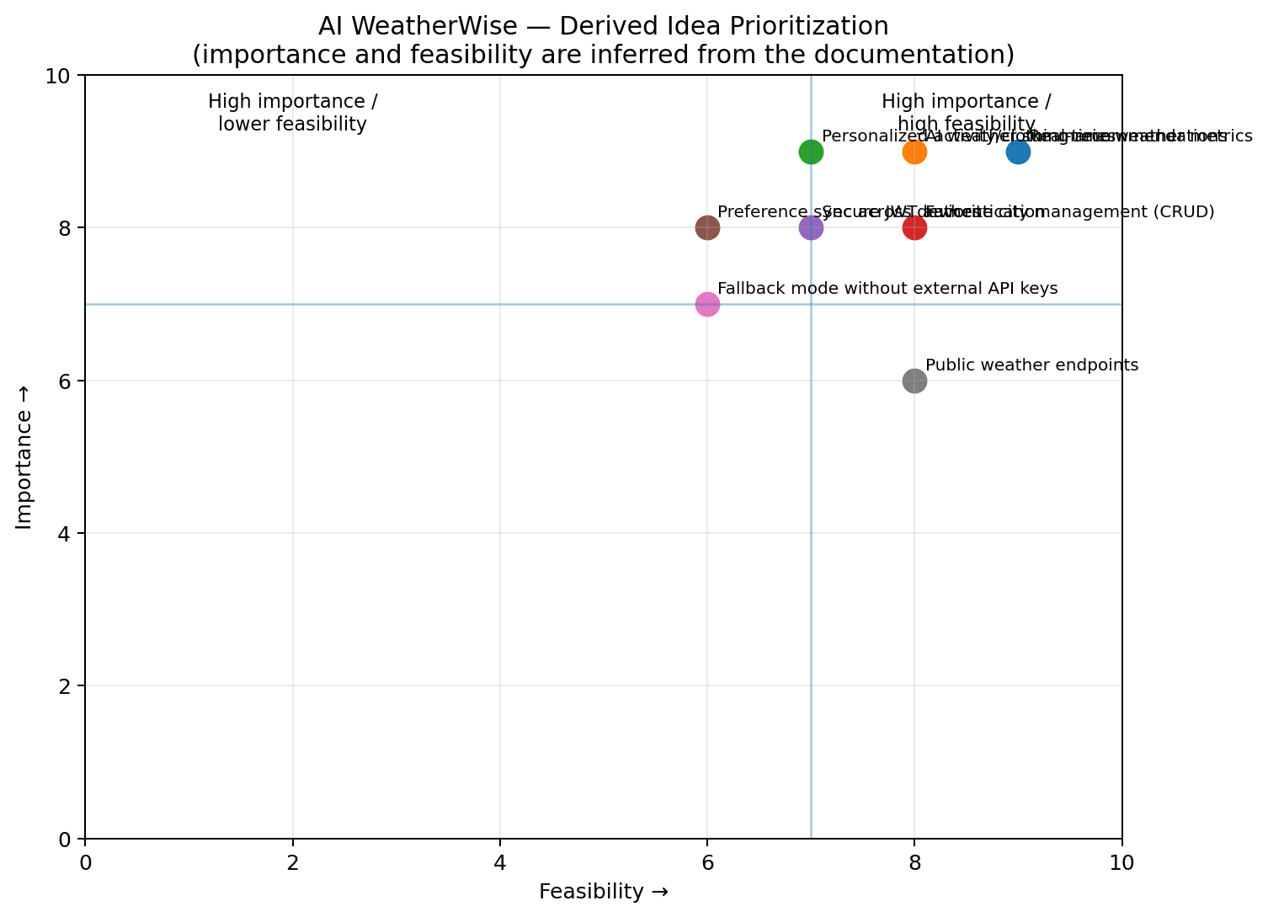
Prioritization reference table
Idea | Importance | Feasibility
Real-time weather metrics | 9/10 | 9/10
AI weather summaries | 9/10 | 8/10
Personalized activity/clothing recommendations | 9/10 | 7/10
Favorite city management (CRUD) | 8/10 | 8/10
Secure JWT authentication | 8/10 | 7/10
Preference sync across devices | 8/10 | 6/10
Fallback mode without external API keys | 7/10 | 6/10
Public weather endpoints | 6/10 | 8/10

Template Image References Used
The original template visuals are included here to retain the image-based structure and reference used for the completed work.

